Name: Ariz Ali
Roll Number: 24K-1044
Assignment 2:
Task 4:
Kindly Note that for Task 5 it was not possible to print the complete log therefore in the folder Task 4 a log file has been pasted for GBN and SR respectively.
Task 5:
GBN
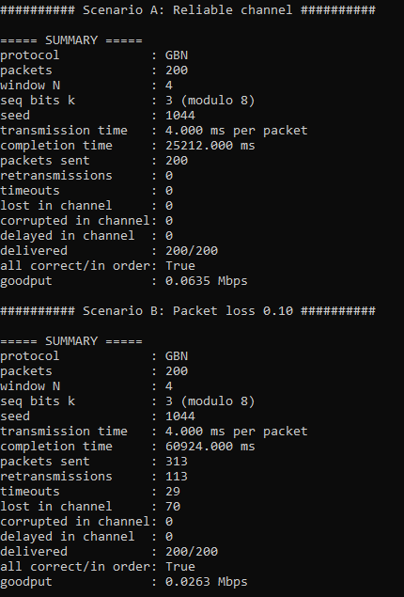
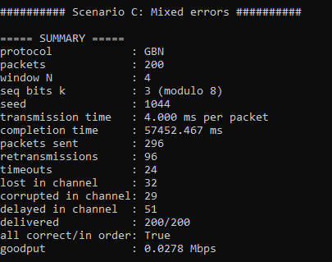
SR:
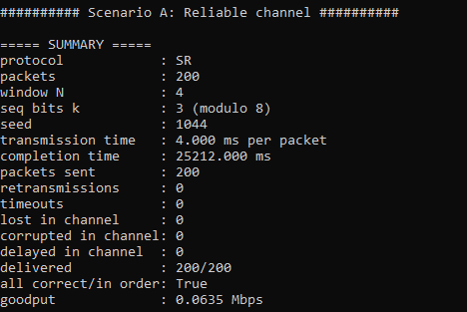

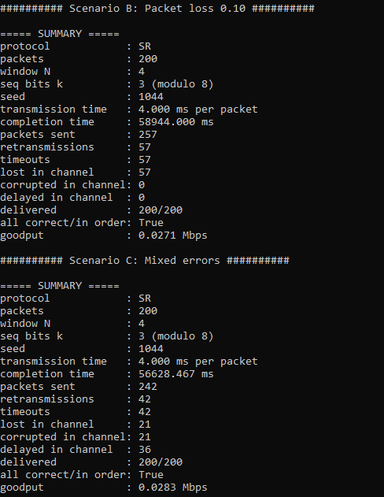
Github Link:
https://github.com/ArizAli23/Computer-Network-Fall-26/tree/main/Assignment%202
Video Link:
https://drive.google.com/file/d/1pLz8a9OJax5zTbbh7kY8MpYKVSfn6lJk/view?usp=drive_link

